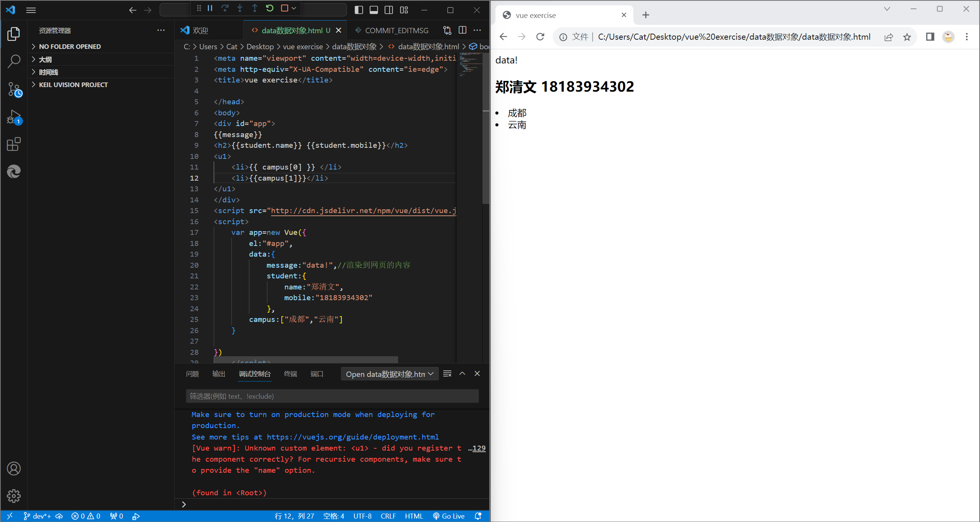

<!DOCTYPE html>

<html lang="en">

<head>

    <meta charset="UTF-8">

    <meta name="viewport" content="width=device-width,initial-scale=1.0">

    <meta http-equiv="X-UA-Compatible" content="ie=edge">

    <title>vue exercise</title>

</head>

<body>

<div id="app">

{{message}}

<h2>{{student.name}} {{student.mobile}}</h2>

<u1>

    <li>{{ campus[0] }} </li>

    <li>{{campus[1]}}</li>

</u1>

</div>

<script src="http://cdn.jsdelivr.net/npm/vue/dist/vue.js"></script>

<script>

    var app=new Vue({

        el:"#app",

        data:{

            message:"data!",//渲染到网页的内容

            student:{

                name:"郑清文",

                mobile:"18183934302"

            },

        campus:["成都","云南"]

    }

})

    </script>

<body>

</html>